Steganography challenges
Steganography Low :
Challenge 1
Used password: 1234567890 in cryptoforge decrypter to get 1234.
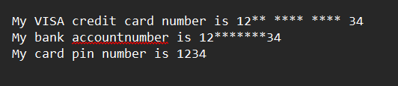
Challenge 2
Used BCtextdecoder and password : 12345678 to get {Y0u_G0T_34SY_P4SSW0RD}
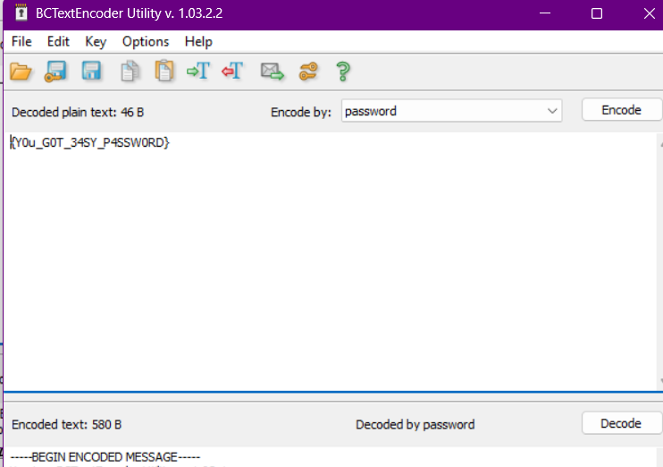

Challenge 3
File name | Excepted sum | Actual | Verdict
Document.txt | D41D8CD98F00B204E9800998ECF8427E | D41D8CD98F00B204E9800998ECF8427E | Match
Excel.xlsx | AB02485A698EDFE66F363B8033ACDC63 | ab02485a698edfe66f363b8033acdc63 | Match
Image.bmp | D41D8CD98F00B204E9800998ECF8427E | D41D8CD98F00B204E9800998ECF8427E | Match
Thala.jpeg | 24F2632925D821FC50901254EBE73721 | 7f70b3544005ccc2e11a195d6435b622 | Mismatch
Word.docx | F70D7689917A8527B4C12B9EFBE02FDE | f70d7689917a8527b4c12b9efbe02fde | Match
Found this {Detailing_is_Also_Fun} in description section as title of Thala.jpeg and found scissor(ZmxhZ3tkZWZpbml0ZWx5X25vdCF9) in description and it decodes to flag{definitely_not!}.
Challenge 4
Matched the cipher texts of the passwords in the list in sha512 with given cipher text to get letmein123.
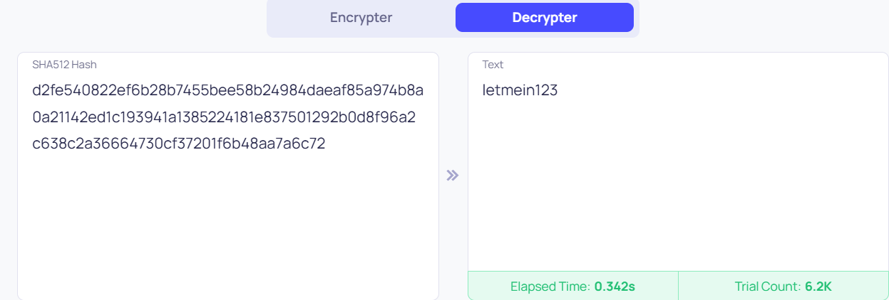
Challenge 5
LOCALHOST-ANONYMOUS is the flag. Used quickstego and got a morsecode which decrypted the flag.
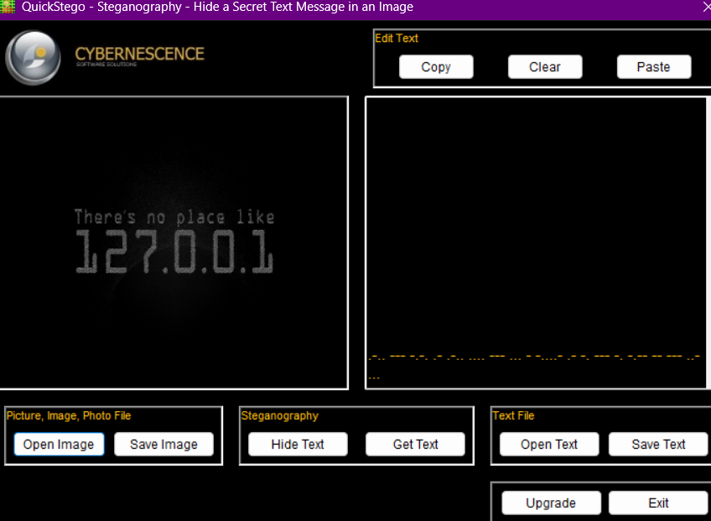
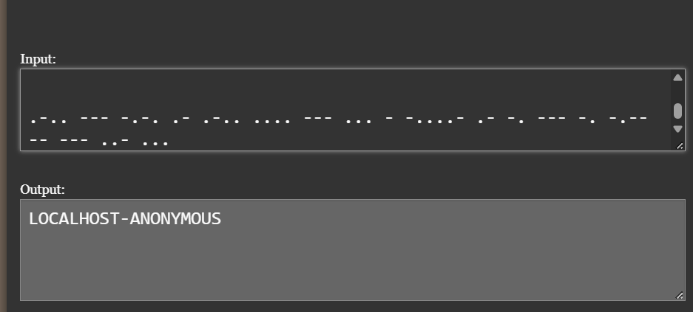
Challenge 6
Using deepsound, found spammimic.txt and decoded that using spammimic online tool and got this {SPAM_STEGANOGRAPHY}.
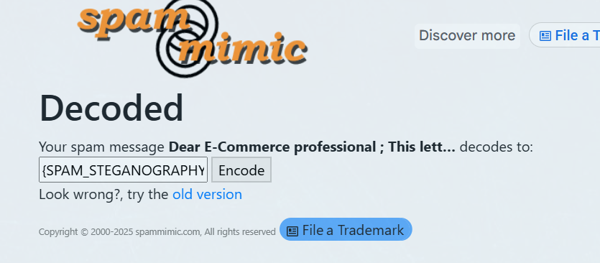
Challenge 7
Chnaged the file type from pdf to txt and used snow tool to get DOCUMENT_STEG HERE IS YOUR FLAG: {JOHNSNOW}.

Steganography medium :
Challenge 1
It is a .wav file so I used deepsound and got two files encrypted inside. Used the password inside secret.txt to crack a file named Challenge-3.txt using BCtext decoder and got {YOU_CRACKED_THIS!!!}.
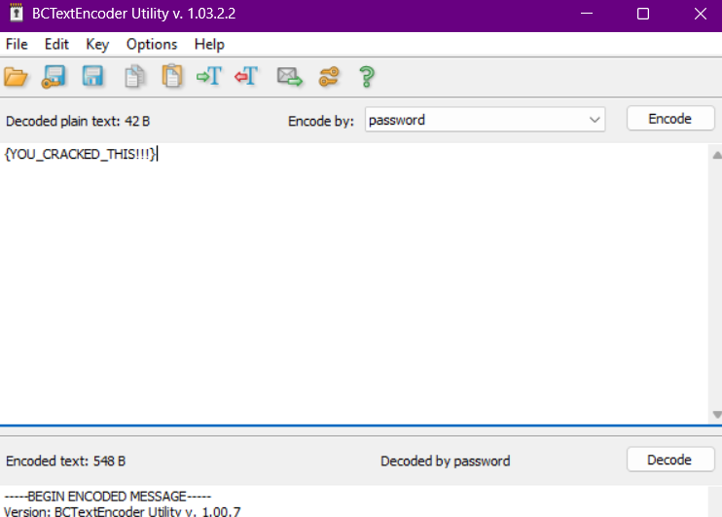
Challenge 2
Used spammimic online tool to get {THIS_IS_YOUR_FLAG: H4CK3RSA$$EMBLE} from the direct spam message present inside the file.
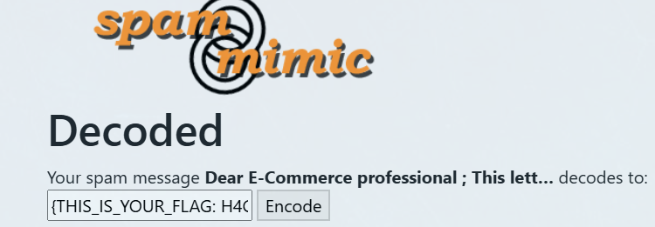

Challenge 3
Got a .wav file so I used deepsound but found no secret files hidden inside. So used an online morse code decoder and got a binary-coded message and converted it into this “!BETTER LUCK NEXT TIME”.
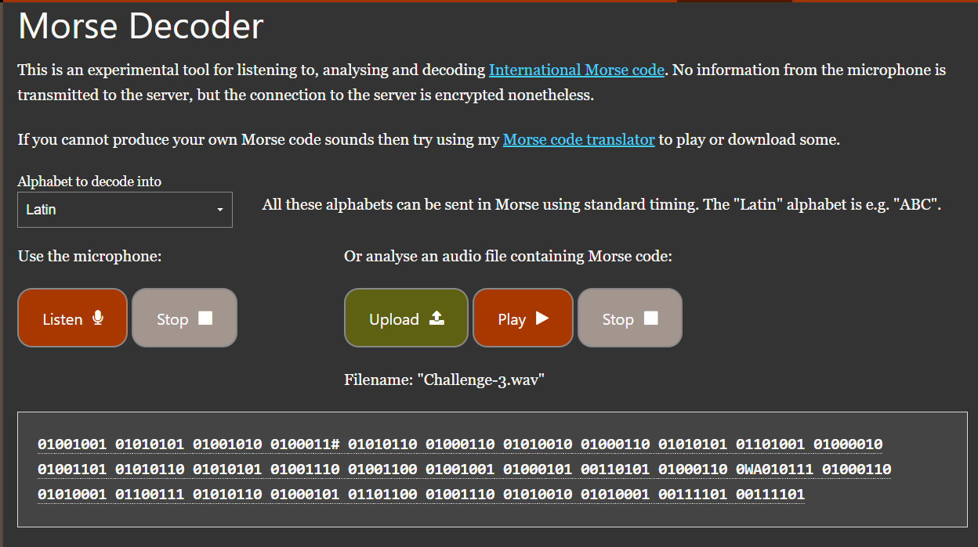

Challenge 4
Got a .wav file so I used deepsound but found no secret files hidden inside. So used an online morsecode decoder and got this HACKERSARETRYINGTOCOMMUNICATETHROUGHASECRETCHANNEL.
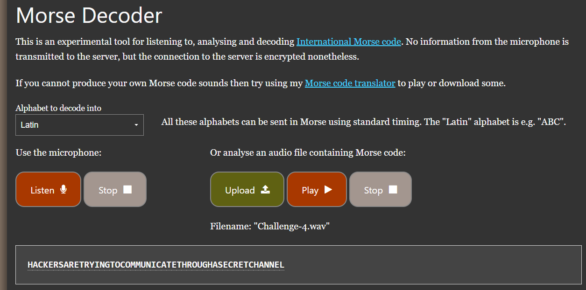
Challenge 5
The folder contains a .webp image and .wav file. Used the text present inside the .webp “BOOYAH!” and got one hidden .pcap file using deepsound on the .wav file. Inside the wireshark network capture file, I have applied the http filter and got two packets and captured an image file “Script_Kiddie.bmp”. Using quickstego, I got a morse code which decoded to “C0NGRATULATIONS!_Y0U_G0T_ME”.
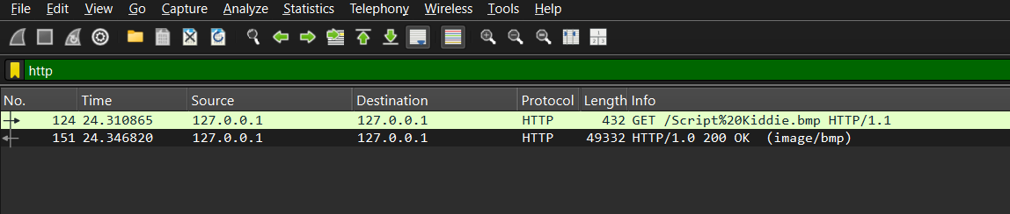
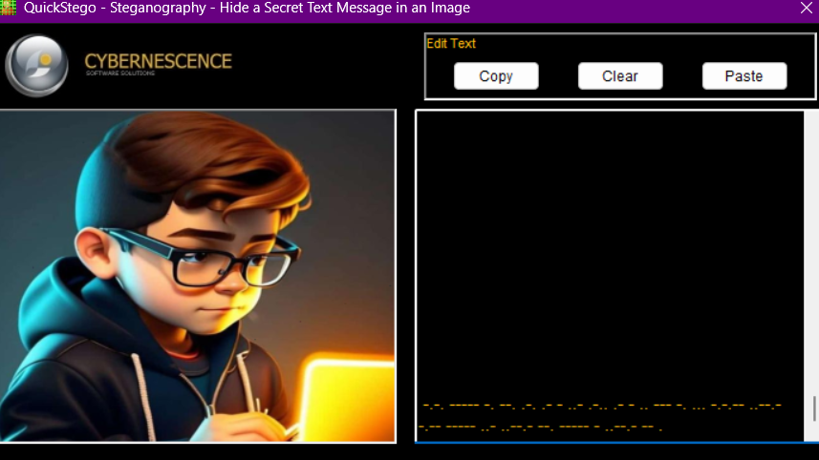

Challenge 6
Using Quickstego to get the hidden text inside the .bmp file and got a spam message, when despammed using spammimic online tool, turend into this .
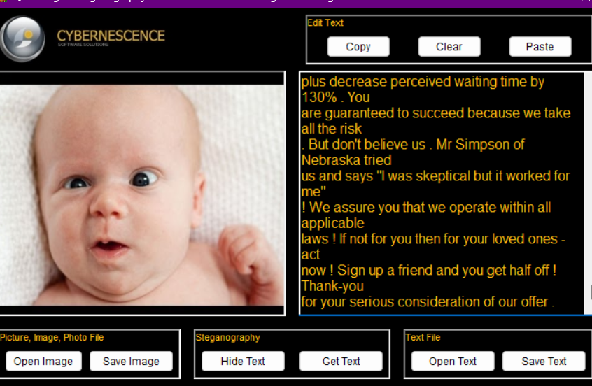
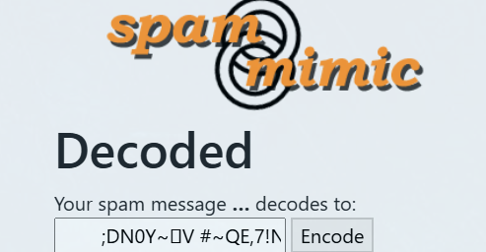

Challenge 7
I couldn’t open the given .pdf file so I tried to change the file type to .txt and now found unreadable text and whitespace in between. So I used snow tool to get this flag “Flag{Wh1t3_Sp4c3_Steg}”.
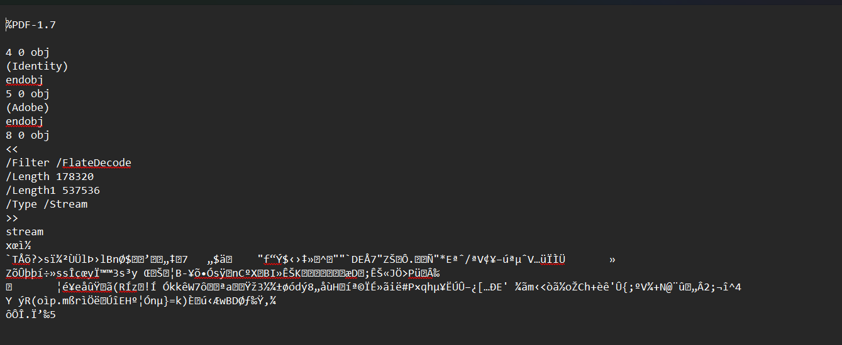
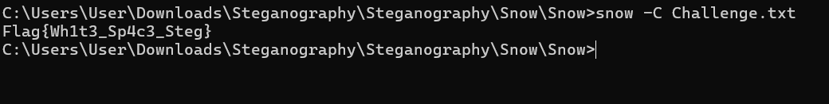

Challenge 8
Got a plain meme in the given image file. Converted it into .rar file and extracted it to get challenge-8 file which contains this text "AHH_YOU_FOUND_ME!" and a file name “hackerchat.png”. So I’ve opened the archive in WinRAR and got “hackerchat.png”. which contains the text “H4ck3r Ch4tz”.
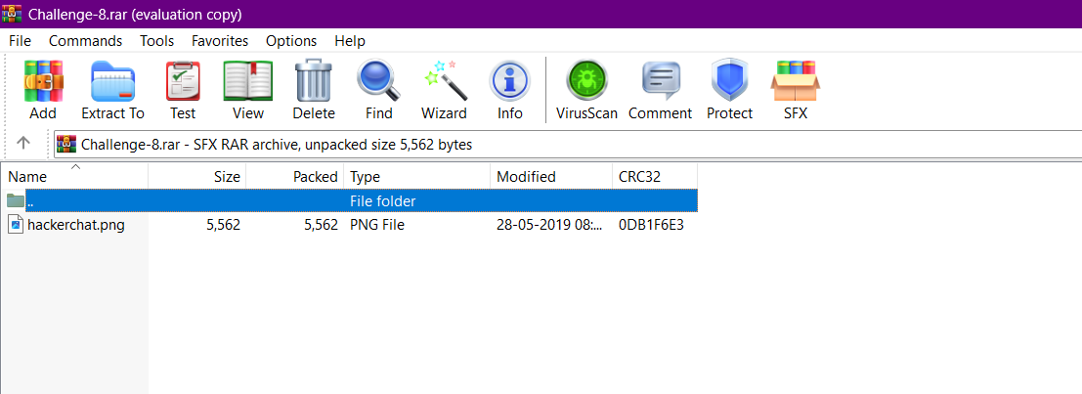

Challenge 9
Found the text “{ENCRYPTION_BLOWFISH_ALGORITHM}” inside the Challenge-9.bmp file using quickstego. I changed the file extension of secret_file.docx to .txt and found empty document so I checked for whitespace encoding using snow tool and got “th1s_is_phrase”.


